# CS 340 README Template

Jacob Simmons

*Use this template to complete your README file. When completing the template, keep the headings as they are so that your document has a clear organization. Remove the italicized prompt text after you have completed each section for a polished final document.*

## About the Project/Project Title

*Provide a little information about your project or an overview that explains* ***what*** *the project is about.*

This project is designed to allow the user to search a large database of dogs with differing traits such as breed, age, location, sex for rescue. This databased is ran using MongoDB with python generated APIs.

## Motivation

*This is a short description of the motivation behind the creation and maintenance of the project. This should explain* ***why*** *the project exists.*

The motivation for using MongoDB is due to the No-SQL abilities of MongoDB and its ease of communication with files specifically when it comes to integrating with Python. The creating the basic CRUD functionalities in Python as simple and integrate very well with MongoDB.

## Getting Started

*This is an example of how you may give instructions on setting up your project locally: “To get a local copy up and running, follow these simple example steps.”*

## Installation

PyCharm was used to generate the .py file and then Jupyter Notebook was used to link all the files together for testing. MongoDB was ran using a Linux system where the Linus and Mongo shells were established for unique purposes.

## Usage

*Use this space to show useful examples of how your project works and how it can be used. Be sure to include examples of your code, tests, and screenshots.*

### Code Example

*Show what the library does as concisely as possible. Developers should be able to figure out how your project solves their problem by looking at the code example. Make sure that your code is short and concise.*

Below is an example of the CRUD python code that was generated.

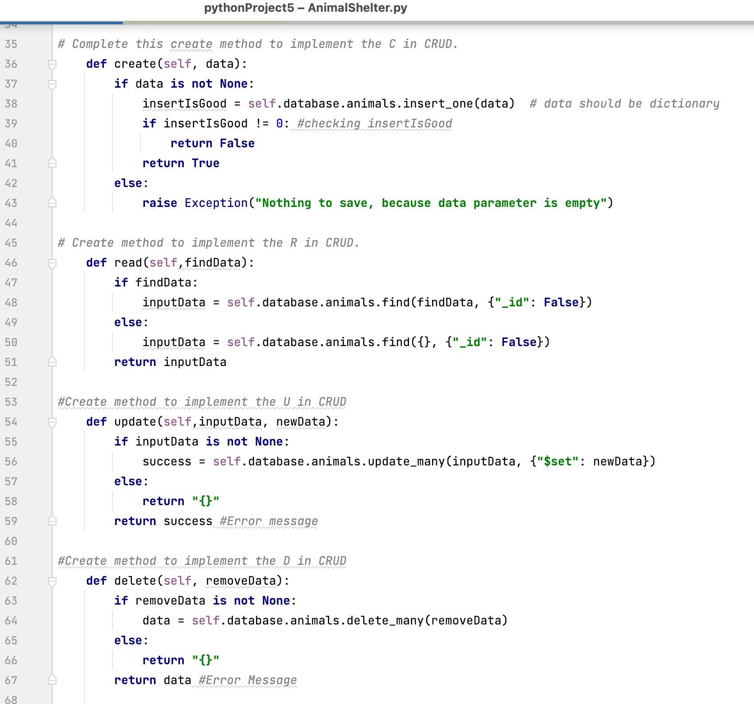

### Tests

*Describe and show how to run the tests with code examples.*

Below are a few of the tests scripts that were executed in Jupyter notebook

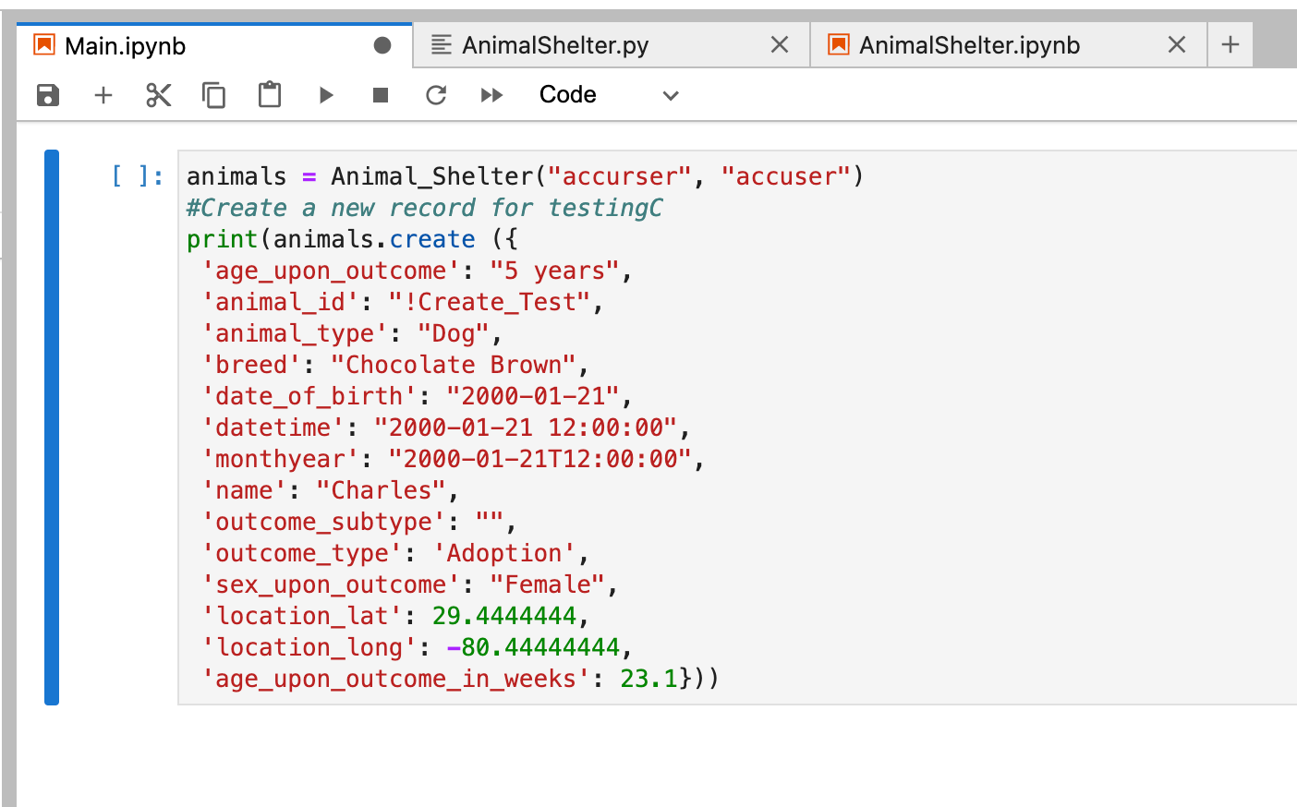

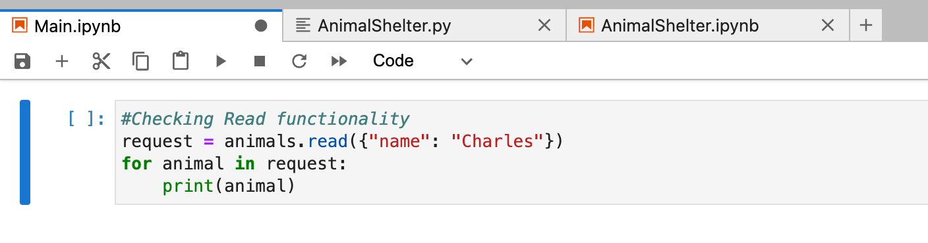

### Screenshots

*Provide screenshots that demonstrate your work.*

The screenshots are provided above

## Roadmap/Features (Optional)

*Provide an open issues list of proposed features (and known issues). If you have ideas for releases in the future, it is a good idea to list them in the README. What makes your project stand out?*  
The open issues I encountered were related to the testing aspects. I was not able to accurately link the individual files to ensure the testing executed as expected. I need to do more research regarding the integration. I would be helpful if there was perhaps some instructor led videos providing examples, however there are other resources available that could be helpful as well.

*Note: This section is optional for the purposes of this assignment. If you choose not to fill out this section, remove it from your final README file.*

## Contact

Your name: Jacob Simmons